**A**

**Project Report**

**On**

**“WEBSITE FOR Sai sanskruti multipurpose hall”**

**In**

**HTML**

**SUBMITTED TO,**

**SHIVAJI UNIVERSITY, KOLHAPUR**

**IN THE PARTIAL FULFILLMENT OF AWARD OF DEGREE**

**Bachelor of Computer Application (BCA-II) (Sem-IV)**

**SUBMITTED BY,**

**Miss. Khurd Yogita Mahesh.**

**Miss. Malwade Mukta Narendra.**

**UNDER THE GUIDANCE OF,**

**Miss. Patil P. H.**

**THROUGH,**



**THE PRINCIPAL,**

**Smt. Kusumtai Rajarambapu Patil, Kanya Mahavidyalaya.**

**(Arts, Commerce & Science) Islampur,**

**Tal:-Walwa, Dist:-Sangli**

**Year:-2019-2020**

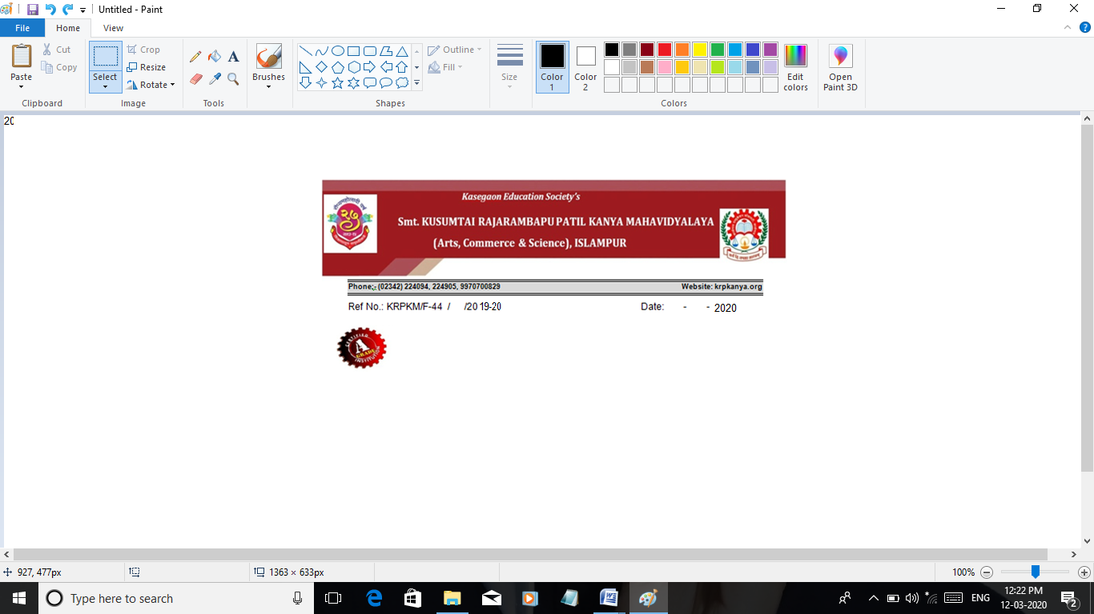

**CERTIFICATE**

This is to certify that, Miss. Khurd Yogita Mahesh & Miss. Malwade **Mukta Narendra** have submitted their project report entitled **“Website for Sai Sanskruti Multipurpose Hall”** for **“Sai Sanskruti**”. In partial fulfillment of the award of degree course **“Bachelor of Computer Application (BCA-II) (Sem- IV)”**affiliated to ShivajiUniversity, Kolhapur.

To the best of our knowledge and belief, matter presented in this project report has not been submitted earlier and it is their original work.

**ProjectGuide Examiner H.O.D.**

(Miss. Patil.P.H) (Prof .Patil. D. A)

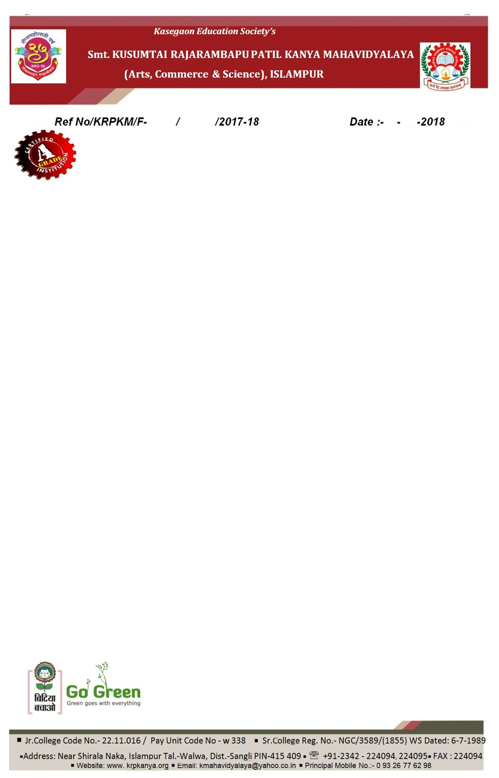

**DECLARATION**

To,

The Principal,

K.R.P. Kanya Mahavidyalaya,

Islampur.

Respected sir,

We undersigned hereby declare that, the project report entitled **“Website For Sai Sanskruri Multipurpose Hall”** is developed for “Sai Sanskruti” and submitted by us under the guidance of **Miss Patil P. H.** is our original work.

The empirical finding in this report is based on the information collected by us. We have not copied and matter from any report. This work is humbly submitted to Shivaji University, Kolhapur for the award of Bachelor of Computer Application (B.C.A) by us.

Thanking you

Miss. Khurd Yogita Mahesh.

Miss. Malwade Mukta Narendra.

**Place**: Islampur

**Date:** / /2020.

**ACKNOWLEDGEMENT**

This is our great pleasure in submitting this project entailed **“Website for Sai Sanskruti Multipurpose Hall”** to Shivaji University, Kolhapur.

We are very sincerely expressing our thanks to Prin. Dr. Kuralapkar. R. M. for providing we required facilities to complete this project. We also thanks to Prof Patil D. A. head of the Computer Science department who encouraged us.

We are thankful to our guide Miss. Patil P. H. valuable Guidance and kind help during completion of our project report.

We are hearty thanks to all of them who helped me directly or indirectly to complete this project smoothly.

Thanks to all

Miss. Khurd Yogita Mahesh.

Miss. Malwade Mukta Narendra.

**Place**: Islampur.

**Date:** / /2020.